Appeal to An Coimisiun Pleanala

Re: Planning Application D26A/0008/WEB
(Beechlands House, Barn Close, Shanganagh Road)

Granted permission by Dun Laoghaire Rathdown Co. Council (DLRCOCO) 15th September 2026

Appellant:
Faye Walsh Drouillard
Florenceville
Shanganagh Road
Shankill
Co. Dublin

Prepared and submitted on behalf of Faye Walsh Drouillard by:
David Hickie (MSc. Environmental consultant)
The Mews
Tinna Park House
Kilpedder
Co. Wicklow
A63CF58

SUMMARY OF GROUNDS OF APPEAL

The overall thrust of our appeal to the above planning permission granted by DLRCOCO on 15 September 2026 is that the proposed development would remove much of the woodland, the ecological impact would be devastating, and it would seriously degrade the residential amenity of the neighbourhood. The density and extent of the housing proposed and the extent of hard urban surfaces would cover much of what is currently woodland and grassland, one of the very few remaining spaces in Shankill for nature to survive and a cultural and visual amenity for the neighbourhood. Furthermore, the permission and attached conditions do not address our concerns about the impacts of the proposed development for the neighbouring property of Florenceville, a protected structure.

By granting permission with very little beneficial amendments to that originally proposed by the developer, the Council has in effect dismissed our concerns and our grounds for refusal, in favour of mitigation measures in the conditions of planning permission. We strongly submit that these mitigation measures are no more than damage limitation; they do not address our concerns. If this development is allowed to proceed, the damage would be wholesale. We submit that this development is completely inappropriate for the Shanganagh Road area and should be refused on appeal.

Our grounds for appeal are detailed below.

In the text, we refer to An Coimisiun Pleanala as the ‘Board’.

1. The proposed development does not respect the residential amenity of both the protected structure of Florenceville and the surrounding area. We are especially concerned that the drastic removal of woodland on the northern border of the site would detract from the privacy of the occupants of Florenceville and would allow overlooking into the property from the housing as currently proposed, and thus severely detract from the existing residential amenity. Therefore, the application in its current form should be refused.

2. The proposed facilitation of public access to Shanganagh Castle — in its current form — would allow the public to enter to the rear of the ruins and to the front of Florenceville and further affect the occupants’ privacy. The proposed removal of so much woodland on the northern part of the site adds to our concerns in this respect.

3. The proposed development is premature, and should be refused, pending the planned improvement of Shanganagh Road. If allowed to proceed before road improvement, the proposed development would add to the already severe traffic congestion, both at the construction phase and especially on completion.

4. Planning in the Shanganagh Road area over the years has been piecemeal and, if permission is granted, it would not follow a joined-up, integrated approach that the Council has commendably embraced in principle in its Development Plan. We cite a previous decision by DLRCOCO that appears to strongly undermine the case for development on the site.

5. The proposed clearance of 75 per cent of the woodland on the site would be a drastic and extreme measure. The development in its current form would severely detract from the residential and visual amenity of the neighbourhood and should be refused on this ground.

6. The nature conservation value of the site, and the role of the habitats within the site with respect to their connectivity with the network of other locally important and nationally important sites has not been properly valued. This site forms an integral part of the ecological network of the county. The latter has been emphasised in the current Development Plan. The development would have a significant impact on the ecology of the area and should be refused on this ground.

1. The proposed development does not respect the residential amenity of the protected structure of Florenceville and its surroundings

New housing would be built very close to the northern boundary of the site, adjoining Florenceville, which would involve drastic and extensive removal of trees and woodland. The existing woodland that forms a screen of trees between the site and the adjoining property of Florenceville would be severely reduced, and we are not satisfied with the developer’s proposed mitigation measures, including tree planting. In any case, since housing is proposed so close to the northern boundary with Florenceville, it would be very difficult for any mitigation measures to be effective. In the short and medium term, the residential and visual amenity of Florenceville would be severely impacted and the proposed development should be refused on this ground.

We are especially concerned that the new units proposed for the northern part of the site could result in the occupants of Florenceville being overlooked, thus impacting on privacy.

We are also concerned that public lighting from the development, at both construction stage and on completion, combined with the severe loss of the screen of trees and woodland that is proposed, would seriously detract from the residential amenity of both Florenceville and the surrounding area.

Siting high-density residential units just metres from the boundary with Florenceville constitutes an aggressive, overbearing intervention that fails to respect the setting, curtilage, and residential amenity of Florenceville. This directly breaches Policy HER4 of the DLRCOCO County Development Plan, which mandates the protection of the architectural heritage and settings of Protected Structures.

We attach photographs of Shanganagh Castle viewed from Florenceville, and photos of the woodland on the proposed development site that currently forms a screen for Florenceville and which makes a major contribution to the setting of this protected structure and heritage house (see Appendix 1.)

2. Public access to Shanganagh Castle ruins would detract from Florenceville privacy

The developers propose making public access to the ruins of Shanganagh Castle and, while access is acceptable in principle, in practice, access by the public to the rear of the castle ruins would affect the privacy of the occupants of Florenceville because the boundary between the site and the curtilage of Florenceville is currently a low wall (that is, the boundary is porous) and the public would be able to look in, or enter, to the front of Florenceville, which would seriously detract from the occupants’ privacy. The current boundary wall is not fit for purpose in the event of any development on the site.

A minimum requirement — as part of a much smaller residential development that we propose as an alternative (see “A suggested alternative to the current proposal”, at the end of this submission) — would be a robust, visually appropriate boundary treatment. To protect the residential amenity and ensure security, a two-metre high natural stone wall (rendered in keeping with local historical stone masonry) would have to be built on the property boundary before any construction begins.

A robust, two-metre high stone boundary wall is also essential to facilitate any future plans the occupants of Florenceville may have, in the context of the current planning application.

3. Shanganagh Road and traffic congestion

The proposed development is premature, pending the upgrading of Shanganagh Road, which is an objective in the current DLRDP. Dun Laoghaire-Rathdown County Council frequently refuses planning permission for residential developments on the grounds of being "premature" pending necessary road improvements and infrastructure upgrades. These refusals, cited in accordance with the County Development Plan, highlight deficiencies in traffic capacity, pedestrian safety and road connectivity.

The previous grant of planning permission for this site (in 2017), cited by the developer as justification for granting permission now, does not take into account the additional, piecemeal development along, and leading into, Shanganagh Road, and the general, sizeable increase in traffic in the intervening nine years.

The developer’s Traffic and Transport Assessment (Section 7.0, page 28) states that: “The proposed development shall generate only modest vehicular traffic flows. Total vehicle trips (arrivals and departures combined) of 21 PCU are predicted during the AM peak hour, and total vehicle trips of 22 PCU in the PM peak hour. Vehicular traffic related to the proposed development shall result in maximum increases in traffic at any existing junction of 1.2% during the AM peak hour and 1.3% during the PM peak hour.”

We submit that the proposed development would contribute to generating an unsustainable amount of additional traffic on Shanganagh Road, which is already at or over capacity at peak times, prior to the road widening planned by DLRCOCO. It is the cumulative effect of the piecemeal developments along, and leading into, Shanganagh Road that the Board should take into account when deciding on this application.

Traffic congestion on Shanganagh Road has been highlighted regularly by local residents and elected councillors, and this congestion is particularly acute during morning and school-run hours, often with traffic backing up from the St. Anne’s/Dublin Road roundabout past the Commons Road junction. Shanganagh Road frequently experiences knock-on delays as drivers attempt to avoid congested motorway traffic on the N11/M50. There is already a traffic bottleneck at the roundabout junction of Shanganagh Road and Dublin Road. Shanganagh Road serves as a primary exit point for traffic for approximately 3,000 homes in South Killiney en route to Bray or the N11.

During the construction phase (which could last a year or more, and construction projects are often subject to delays) substantial additional traffic congestion would be generated on this narrow, winding, unimproved section of Shanganagh Road due to construction vehicles and staff entry, exit and parking.

We submit that, regardless of national housing strategy and guidelines on housing provision and density, Shankill is already at or over capacity with regard to traffic generated by residential development in the last decade. The proposed development would contribute to generating additional, unsustainable levels of traffic on Shanganagh Road that would seriously detract from residential amenities, would therefore be contrary to good planning and development practice and the Board should refuse permission on this ground.

4. Piecemeal planning along shanganagh Road: traffic congestion and DEGRADATION of residential amenity and ecology
The developer’s Planning Report states: “The fact that a grant of permission was previously issued serves as evidence that a residential development of this nature is considered suitable for this location and aligns with the objectives and policies of the DLRDP.”

Planning in the Shanganagh Road area over the years has been piecemeal, and, if permission is granted, it would not to follow a joined-up, integrated approach that the Council has embraced in principle in its current Development Plan. A previous decision by DLRCOCO undermines—does not support—the case for development on the site: DLRCOCO refused an application for an apartment complex on Shanganagh Road, and one of the grounds for refusal was:

“The proposed development is premature pending the completion of the design and construction of the Shanganagh Road Improvement Scheme and as such the proposed development would create a serious road safety and traffic hazard, which would be contrary to the proper planning and sustainable development of the area.” (Dun Laoghaire-Rathdown Co. Co. Planning Reference D07A/0709, 2007).

Shanganagh Road has still not been improved and piecemeal development has been allowed in the area since this decision. This piecemeal planning has contributed to generating an unsustainable level of traffic and has further eroded the residential amenity and ecology of the area.

The developer’s design operates in isolation rather than integrating organically with the Woodbrook-Shanganagh Local Area Plan. The layout would perpetuate a pattern of piecemeal development that would degrade the cohesive suburban fabric of the area, failing to meet the Council's stated core strategy for integrated, sustainable communities.

We submit that piecemeal planning is inconsistent with the current Development Plan, and the Board should refuse the application on this ground.

5. Woodland clearance would lead to a major DEGRADATION of residential amenity

The development in its current form would, due to the proposed large-scale woodland clearance, severely detract from the residential and visual amenity of the neighbourhood.

The proposed clearance of 75% of the woodland on the site is a drastic and extreme measure. The developer’s justification for permission rests on the previous grant of permission in respect of this site, which was in 2017, when the previous development plan was in force.

In the Updated Ecological Assessment (EcIA) Report, 9.1 Summary of Significant Effects, it is stated: “The proposed development will result in a significant loss of trees and canopy coverage, reducing the current ecological role of the site as a biodiversity corridor.”

We draw the Board’s attention to the internal report by the Parks and Landscape section of DLRCOCO (Ref: EM 14066) strongly recommends refusal. We agree emphatically with this report. (See Appendix 3. Extract from this internal report.)

The current DLRDP 2022-2028 includes provisions that strengthen the protection of biodiversity, with specific objectives to safeguard trees and woodlands. We submit that the proposed removal of three-quarters of the tree cover from the site is contrary to the objectives of the current DLRDP. We also submit that the proposed removal of so much of the tree cover from the site is contrary to the strengthened objectives of the current DLRDP with respect to maintenance of green corridors in the county, and specifically in relation to the existing green corridor provided by the woodland on the site and Loughlinstown Wood (see DLRDP 2022-2028, page 45). While replacement tree planting is proposed, the existing link to the green corridor identified in the Development Plan would be effectively severed in the short and medium term.

The EcIA report states that the site needs to be managed (including removing certain invasive species and some non-native trees at the end of life), but this proposed high density development cannot replace the large areas of green space and woodland that would be sacrificed for this development. It would take decades for the proposed re-planting to have any beneficial ecological effect, and the very extensive hard surfaces proposed would do permanent damage to the nature conservation value of the site.

The trees and woodland on the site have been a very important part of the residential amenity for well over a century, particularly for the residents of Florenceville and Mill Lane, to the north of the site. The proposed removal of so many trees on the site would drastically change the character of the neighbourhood. When the Shanganagh Road Improvement Scheme has been completed, an appropriate development would be of a much smaller scale and would entail reducing the housing density, which is a valid reason considering that the category of zoning for development in this area of the county includes the protection of residential amenity. This would also be in agreement with the Council’s current Development Plan with regard to tree and woodland conservation and green corridors, and only those trees that pose an immediate danger should be removed. We elaborate on this at the end of this submission.

We submit that the proposed removal of 75 per cent of the tree cover on the site is not consistent with the Council’s Tree Strategy. DLRCOCO’s Tree Strategy 2024-2030 in relation to development sites states, on Page 30: “…the priority should always seek to maximise the retention of existing tree and hedgerow cover.” We observe that the developer proposes the opposite: To maximise housing density on the site and to minimise the amount of tree cover on the site. Thus, the planning application fails to meet the Council’s own criterion in this regard.

6. The development would have a significant impact on the ecology of the area

The nature conservation value of the site, and the role of the habitats within the site with respect to their connectivity within the network of other locally important and nationally important sites has not been respected. This site forms an integral part of the ecological network of the county. Ecological networks are emphasised in the current Development Plan. We submit that the development would have a significant impact on the ecology of the area. We detail this below.

The developer’s Ecological Impact Assessment Report states: “Development of two private estates in their current configuration would still likely involve considerable alteration of on-site habitat, especially given the presence of over fifty trees for which “removal would be seen necessary either now or in the short-term as the most appropriate management option” (see Appendix D of the above report). We submit that this is NOT the most appropriate management option except to facilitate the developer’s plans to maximise the density of housing on the site.

The Ecological Assessment Report includes a map (Figure 4.6 of the report) that shows the distribution and extent of the habitats within the site of the proposed development (see Appendix 2 of our submission, below). It can be clearly seen that mixed broadleaved woodland covers the majority of the site (area coloured brown). The report states: “The site features quite dense tree coverage particularly to the north and south. This habitat is highly suitable for commuting and foraging birds and bats”. Supporting our case, we attach a Google satellite image taken from the developer’s report showing the extent of tree and woodland cover on the site (see also our Appendix 2, below).

The Arborist’s Report (Appendix D of the developer’s Ecological Impact Assessment Report, page 6) states that: “There is heavy tree cover on this site area particularly to the front of the site where the entrances to both main houses come through with the most prominent area of trees containing Beech, Ash and Sycamore with other tree species in smaller quantities including a number of conifers and Eucalyptus.”

In order to accommodate the proposed housing, apartments, roads and other structures, the majority of this woodland would have to be removed. This would be a drastic measure, almost equivalent to a clearfell in forestry terms, and even though the quality of the majority of the trees are reported to be poor from an arboricultural perspective, nevertheless from a nature conservation perspective they have an important role. From a nature conservation perspective, this woodland has a mix of young, mature, old, dead and dying trees, and all play their roles in the ecology of a living woodland.

We ask the Board to examine the planning files for any precedents for such extensive removal of woodland to facilitate residential development in the suburban areas of Dun Laoghaire-Rathdown in recent years. The proposed development constitutes a drastic change to the setting, residential and visual amenity, and ecology of the neighbourhood. We therefore submit that the proposed development should be refused on the ground of the severe impacts it would have on the local ecology.

A suggested alternative to the current proposal

We understand that the Council is committed to high density housing in Shankill. Given the serious threats to the ecology of the site, reduction of value as a corridor for nature, destruction of residential amenities and the landscape of the area, and overcrowding and exacerbation of the already excessive traffic buildup that would result from the proposed development, we suggest an alternative.

The alternative would be to isolate (re-zone) a section of the site for high density development with a much reduced ecological, landscape and traffic footprint, and which would respect the residential amenities of the area. We understand that the existing properties on site are in need of extensive renovation. We also understand that it is desirable to manage this site for a variety of reasons. There is space adjacent to, and surrounding, Beechlands and Barn Close for a quality, high density development that would have a much lesser impact on the current value of the site.

We further propose that the Council could acquire the most valuable parts of the site for amenity, nature conservation and for enjoyment by both the existing residents and the new occupants.

The Council could meet its commitment to high density residential development, on a smaller scale, and protect, as far as possible, the existing value of the site for amenity, recreation and nature conservation.

We ask the Board to consider the extent to which the proposed development would negatively impact the residential amenity of Florenceville and Mill Lane and the wider residential amenity of the neighbourhood, the traffic generated by piecemeal development over the years, and the generation of even more traffic from the proposed development. The proposed removal of 75% of the trees and woodland on this site would effectively obliterate the wider residential amenity and nature conservation of the neighbourhood. This site is one of the few ‘green lungs’ left in this part of Shankill.

If the Board decides to refuse the application, and if it is re-submitted at a later date, after Shanganagh Road improvements have been completed, it should advise that a future planning application should aim to scale back the plans significantly to respect the residential amenity of Florenceville and to protect the wider residential amenity and ecology of the Shanganagh Road neighbourhood.

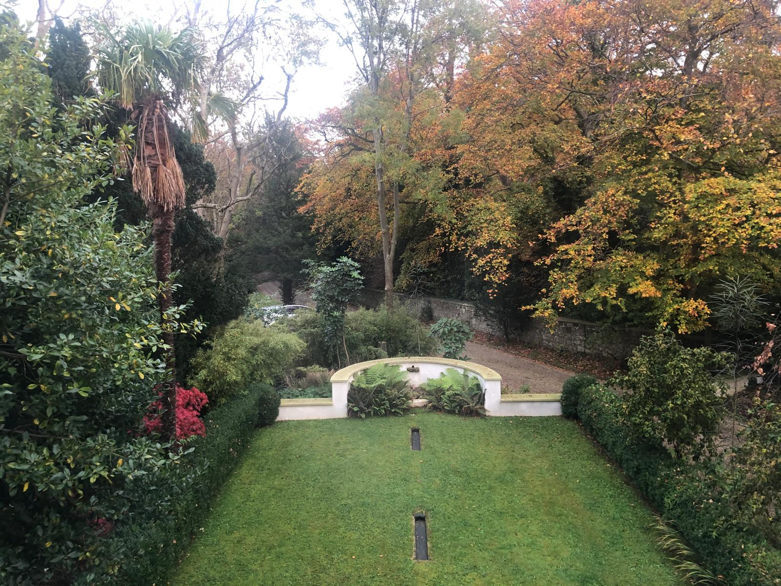
Appendix 1. Photographs of views from Florenceville

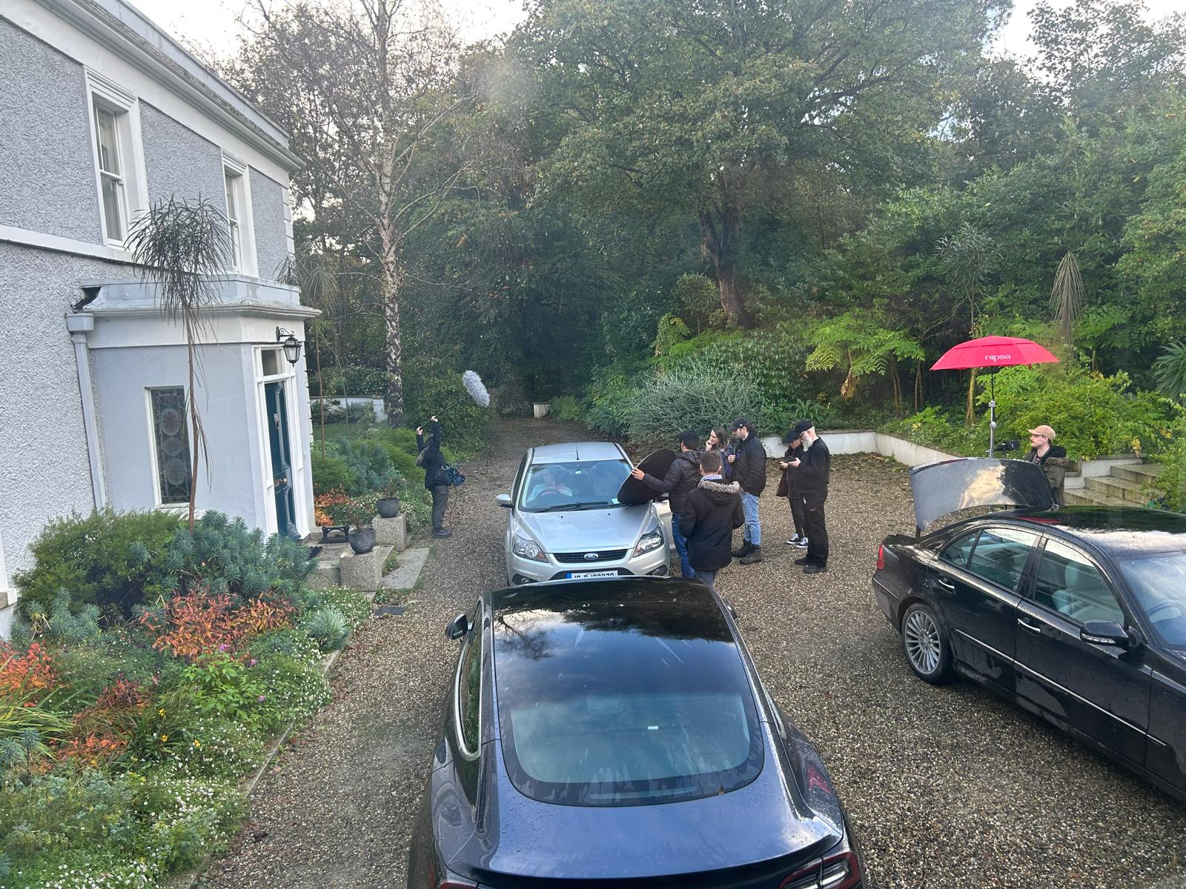
View from Florenceville bedroom towards the proposed development site. Note the screen of trees on the northern boundary of the site, the majority of which are proposed to be removed.

Another view from the front of Florenceville, looking towards the site, showing the screen of trees that are an integral part of the setting of this protected structure and heritage house.

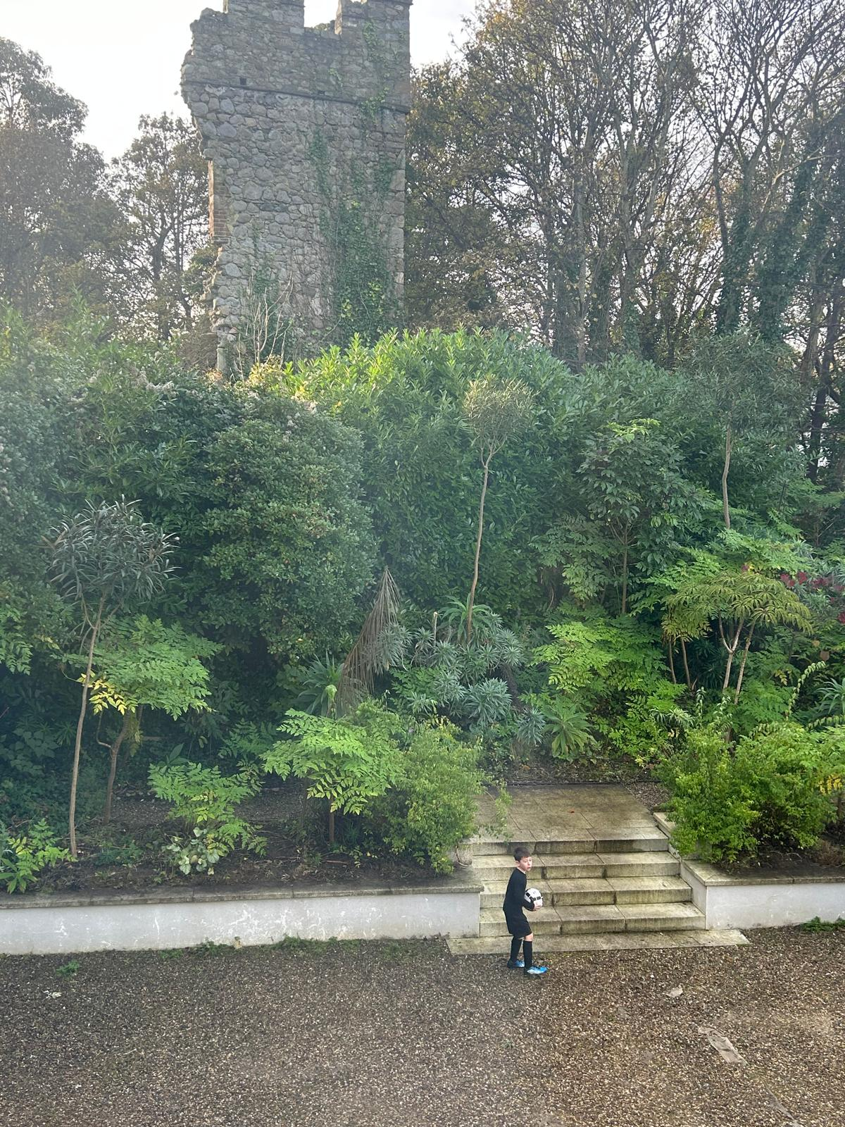
View from the front of Florenceville towards Shanganagh Castle, where public access to the castle and surrounds are proposed, situated within several metres of the boundary between the respective properties. Much of the woodland cover and screen of trees are proposed to be removed along the northern boundary of the site, and the two properties are currently separated only by a low wall. This proposal, in its current form, would seriously affect the occupants’ privacy.

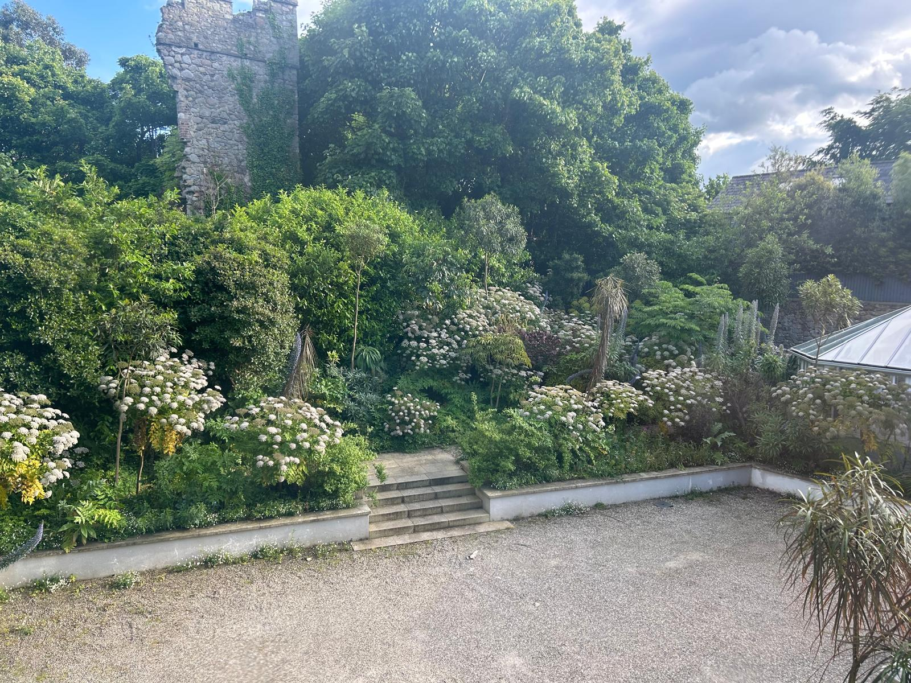
A wider perspective, from Florenceville towards Shanganagh Castle, showing the current screen of trees that forms an integral part of the residential amenity of Florenceville and the wider neighbourhood. This screen of trees is proposed to be substantially removed.

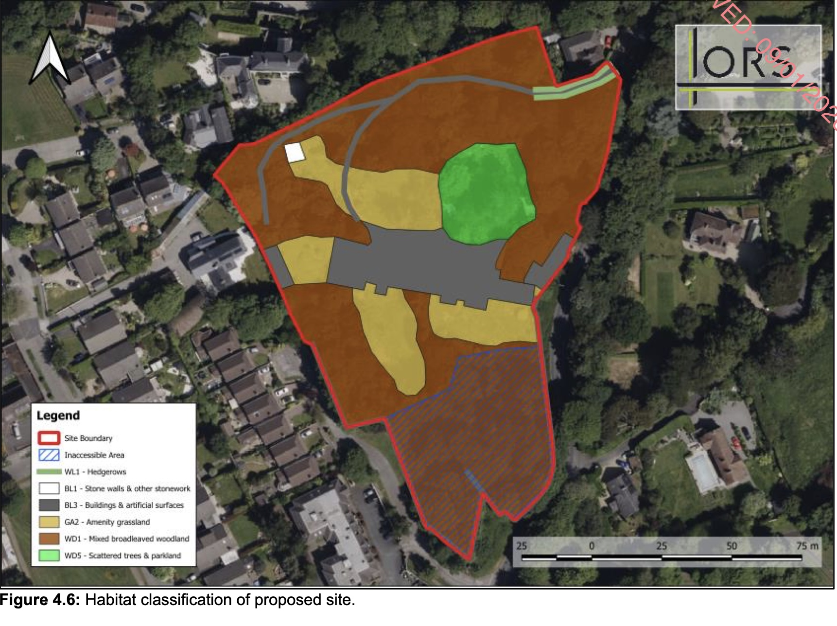
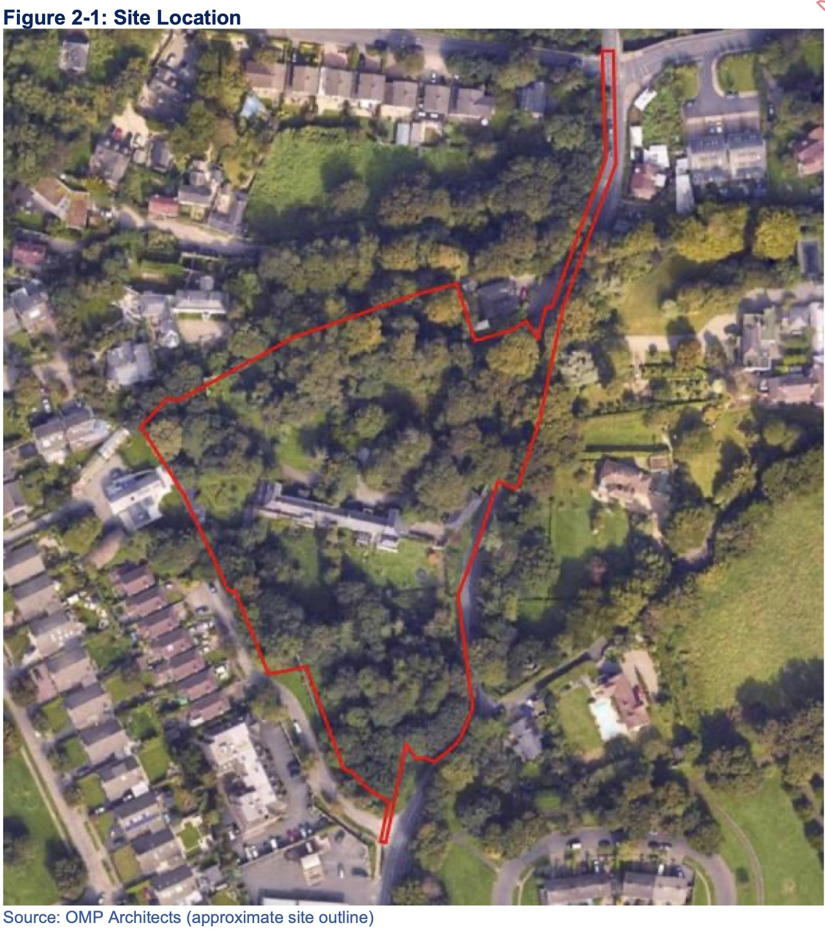
Appendix 2. Figure and map showing extent of woodland cover
Extracts from the developer’s report, showing the habitats recorded on the site (above), and a Google satellite image (below). Mixed broadleaved woodland comprises the majority of the proposed development site, 75% of which would be removed.
APPENDIX 3. EXTRACT FROM INTERNAL REPORT FROM PARKS AND LANDSCAPE SERVICES, DUN LAOGHAIRE-RATHDOWN CO. COUNCIL. REF EM 14182

“In relation to the above proposed development, this section has reviewed the application and has the following comments:

1. Existing trees
According to the Trees and Woodlands Map within the Dún Laoghaire–Rathdown County Development Plan 2022–2028, the site contains seven “tree icons”, a designation that is exceptionally rare within the county. These icons denote trees of significant landscape, ecological, or cultural value and typically correspond to areas of established canopy cover, heritage specimens, and high-value green infrastructure that contribute substantially to the county’s urban forest resource. It is very disappointing to see that little to no effort has been made to retain the majority of trees on site, including Tree No. 1668 (Category A).

“The historic Shanganagh Castle, originating in the 15th century, is recorded on both the First Edition 6-inch Ordnance Survey maps (c.1829) and subsequent 25-inch editions, where dense woodland is shown enveloping both the castle and Barnclose Lodge. This long-standing treed landscape represents an important surviving fragment of the historic estate character, with mature broadleaves forming a distinctive sylvan setting. Such settings are recognised in landscape conservation as critical to safeguarding the historical legibility and contextual integrity of heritage structures.

“This site therefore constitutes one of the last remaining areas of continuous mature canopy and green infrastructure in a wider environment increasingly dominated by hard urban surfaces. The presence of historic specimen trees, likely exceeding a century in age, further elevates its arboricultural value. Their preservation is essential not only for historical continuity but also for maintaining irreplaceable ecosystem services linked to mature trees.

“Despite this, the proposed scheme includes the removal of:
• 1 Category A tree (trees of high quality and value),• 26 of 47 Category B trees (moderate quality),
• 78 of 99 Category C trees (trees with landscape or ecological value despite lesser condition).

“This represents a significant loss of the site’s existing tree structure, with long-term ecological consequences. Category A and B trees in particular form the core ecological framework of any landscape, offering advanced canopy cover, habitat diversity, carbon sequestration capacity, and structural stability that newly planted stock cannot replicate for decades.

“Ecologically, the site supports a valuable semi-natural habitat, functioning as a movement corridor for local fauna, including birds, small mammals, and invertebrates. Mature vegetation corridors are well documented as essential components of biodiversity networks, facilitating dispersal and maintaining ecological resilience within fragmented urban landscapes.

“In addition, the site is of architectural and historical importance, forming the remaining landscape setting of Shanganagh Castle and the associated estate structures. The protection of the landscape context of heritage assets is a core principle of both the National Planning Framework and established international conservation guidelines.

“In alignment with the DLR Tree Strategy 2023–2030 and the objectives of the County Development Plan, there is a clear policy imperative to protect, enhance, and expand the county’s urban forest and high quality tree resource. Furthermore, the EU Nature Restoration Regulation (effective since August 2024) obliges all Member States to ensure no net loss of urban green space or tree canopy cover by 31 December 2030 across both urban and rural ecosystems. The scale of tree removal proposed would therefore appear to conflict with these obligations.

“Overall, priority should be given to preserving and strengthening the site’s sylvan character, which is a key component of the Shankill’s green infrastructure corridor. Mature tree belts contribute significantly to ecological connectivity, visual amenity, microclimate regulation, stormwater attenuation, and the overall environmental quality of the area.
Given the ecological value, heritage importance, and regulatory context outlined above, the Parks and Landscape Section (PLS) consider the proposal to constitute an overdevelopment of the site and recommends refusal of planning permission.”
Submission prepared on behalf of Faye Walsh Drouillard by:

David Hickie (MSc. Environmental Sciences)

Environmental consultant
The Mews
Tinna Park House
Kilpedder
Co. Wicklow

